**网 球 运 动 的 动 量 问 题**



**课程名称 数学实验**

**上课班级：992304-001**

|  |  |  |  |  |  |
| --- | --- | --- | --- | --- | --- |
| **姓名** | **学院** | **年级** | **专业** | **学号** | **点名册序号** |
| **楼洋** | **计算机学院** | **2022** | **计算机科学与技术** | **20221627** | **83** |
| **刘开泰** | **数学与统计学院** | **2021** | **强基数学** | **20210664** | **无** |
| **马福有** | **物理学院** | **2021** | **物理强基** | **20210655** | **无** |

**开 课 时 间 2023 至 2024 学年第 二 学期**

# Capturing Momentum in Tennis : Using Wavelet Analysis and Machine Learning

### Summary

It’s a familiar scene that a player dominates the tennis match, effortlessly moving towards the finish line. But then, out of the blue, their rival snatches a crucial hold or break. Doubts creep into your mind. Why would a player with such a strong lead be broken by his opponent? It’s **Momentum**. To better capture Momentum in Tennis, we conduct in-depth and close studies on this topic from multiple perspectives and levels.

Firstly, to capture the flow of play as points occur and apply it to one or more of the matches. We develop a model based on **wavelet analysis**. **Wavelet analysis** is a technique that decomposes a time series into different frequency components, and reveals the localized variations of power within each component. Our model uses wavelet analysis to extract the dominant modes of variability and the temporal changes of these modes in the point-by-point score data. We then use these modes to measure the performance and the momentum of each player, and to identify the critical points and the swings in the match.

Next, We also use **Random Forests (RF)** model to assess the claim that momentum plays no role in the match, and to predict the point victor in a tennis match based on some features that capture the state of the match and the performance of the players.

Besides,to predict the swings in the match, we use a combination of **Convolutional Neural Networks (CNN)**, **Bidirectional Long Short-term Memory Networks (BiL- STM)**, and **Random Forests (RF)** to process the time series data of the players’ performance indicators. And by analyzing the data, we conclude that the most related factors that influence the momentum of tennis players in a match are the **break points** and the **psychological** factors.

Furthermore, we then use these models to measure the performance and the mo- mentum of each player, and to identify the critical points and the swings in the match. We apply our model to several men’s singles matches from different tournaments, and compare the results with the conventional statistics and the visual observations. We test the performance and generalizability of our model on different matches, tournaments, court surfaces, and sports. We find that our model can capture the dynamics and swings of the match flow, and that momentum is indeed a significant factor that affects the outcome of the match. We also find that some factors, such as serve, break points, and unforced errors, are more related to the changes in the match flow than others. We conclude by providing some advice for coaches on how to use our model to prepare players for different scenarios and opponents.

Finally, we write a memo including our models, results, and advice to coaches on the role of ”momentum” and how to prepare players to respond to events that impact the flow of play during a tennis match. We hope this memo will become a valuable reference for the further development of Momentum in tennis.

**Keywords**: Tennis; Momentum; Wavelet Analysis; Convolutional Neural Net- works; Bidirectional Long Short-term Memory Networks; Random Forests

## Contents

1. Introduction 1
   1. Background 1
   2. Restatement of the Problem 1
2. Assumptions and Notions 1
   1. Model Assumptions 1
   2. Notations 2
3. Data Preprocessing 2
4. Task1: Capturing the flow of play 3
   1. Establishment of the model 3
   2. Result 5
5. Task2: Assess the claim 5
   1. Problem Analysis 5
   2. Whether momentum matters in tennis 7
6. Task3: Predict the swings in the match 8
   1. Establishment of the model 8
   2. Result 9
   3. Analysis of the Model 10
   4. Advice for the Player 10
7. Task4: Test the model on other matches 11
   1. Evaluating the Model on Other Matches 11
   2. Identifying the Factors that Need to be Included in Future Models 12
8. Model Evaluation and Further Discussion 13
   1. Strengths 13
   2. Weaknesses 13
   3. Further Discussion 14
9. Conclusion 14

References 14

## Introduction

### Background

Tennis is a sport that involves a complex interplay of physical, mental, and tactical skills. A tennis match consists of a series of points, games, sets, and sometimes tie-breaks, that determine the winner and the loser. The flow of play, or the relative performance and dominance of each player, can vary significantly throughout the match, depending on various factors, such as serve, return, rally, strategy, confidence, fatigue, and pressure. Understanding and predicting the flow of play is crucial for players, coaches, analysts, and fans, as it can help them make better decisions, improve performance, and enjoy the game more.[1]

However, measuring and modeling the flow of play is not a trivial task, as it involves dealing with noisy, non-stationary, and non-linear data. Traditional methods, such as point-based or game- based statistics, may not capture the subtle and dynamic changes in the flow of play, and may fail to account for the temporal and contextual dependencies among the points. Moreover, different players may have different patterns and rhythms of play, which may affect the flow of play in different ways.[2]

### Restatement of the Problem

Considering the background information, we need to solve the following problems:

* + - **Task1:** Develop a model that captures the flow of play as points occur and apply it to one or more of the matches, which should identify which player is performing better at a given time in the match, as well as how much better they are performing.
    - **Task2:** Use our model to assess the claim that A tennis coach postulates that swings in play and runs of success by one player are random.
    - **Task3:** Develop a model to predict the swings in the match, analyze the factors most related, and give advice to a player going into a new match against a different player.
    - **Task4:** Test the model we developed on one or more of the other matches.

## Assumptions and Notions

### Model Assumptions

To develop a model that captures the flow of play as points occur in a tennis match, we make the following assumptions:

* + - The outcome of each point is independent of the previous points, except for the effect of the serve. That is, we assume that there is no ”momentum” or psychological influence that affects the performance of the players.
    - The probability of winning a point depends on the player’s skill level, which is measured by a rating system such as the Elo rating or the ATP ranking. We assume that the skill level of each player is constant throughout the match and does not change due to fatigue, injury, or other factors.
    - The probability of winning a point also depends on the serve, which alternates between the players every game. We assume that the player serving has a higher probability of winning the point than the player receiving, and that this advantage is proportional to the skill level of the server.
    - The flow of play is represented by a score vector that records the number of sets, games, and points won by each player at any given time. We assume that the score vector follows the rules of tennis, such as tie-breaks, advantage points, and deuce points.
    - The match ends when one player wins the required number of sets, which is usually two for men’s singles and three for women’s singles. We assume that there is no possibility of a draw or a forfeit.

### Notations

The primary notations used in this paper are listed in **Table** **1**. There can be some other notations to be described in other parts of the paper.

Symbol Definition

𝜇 The average of the corresponding features

𝛿 The standard deviation of the corresponding feature

𝑧 The new value after standardization

𝛹 𝑡 Wavelet function of time

( )

𝛹 ∗ 𝑡 Conjugate function of wavelet basis function

( )

𝑊 𝑓 𝑎, 𝑏 The Wavelet Coefficient

( )

𝑃1 𝑠𝑐𝑜𝑟 𝑒 The score of Player P1

𝑃1 𝑠𝑐𝑜𝑟 𝑒 𝐴𝐷 The score advantage of player 1 (the server) over player 2 (the receiver)

𝑃1 𝑠𝑒𝑟𝑣𝑒 The Service performance of Player P1

𝑃1 𝑎𝑐𝑒 The Ace of Player P1

𝑃1 𝑑𝑜𝑢𝑏𝑙𝑒 𝑓 𝑎𝑢𝑙𝑡 The Double fault of Player P1

𝑃1 𝑑𝑖𝑠𝑡𝑎𝑛𝑐𝑒 𝑟𝑢𝑛 The Disance run of Player P1

Table 1: Notations

## Data Preprocessing

Before building the model, a preliminary check of the data in the report is needed. The data we use includes the data files given as **Wimbledon featured matches.csv**.

Firstly, in order to be more convenient to distinguish between different matches, we extracted the numbers from the **”match id”** in the data, for example **”2023-wimbledon-130”**, and extract the following number **”1301”**. Then replace the **AD** in the **”P1 score**” and **”P2 score”** with **45**.

Next, We carried out operations such as missing value filling, standardization and **PCA(Principal Component Analysis)** dimensionality reduction to standardize the data, then carried out **PCA fit- ting**, calculated the proportion of interpretation variance of each principal component, and then

reduced dimensionality through **PCA**, so that the data after dimensionality reduction could be obtained. Finally, we draw a line graph of the accumulated value of the feature after dimensionality reduction, as shown in the **Figure** **1**. In this way, the effect of dimensionality reduction and the contribution of principal components can be intuitively seen.

Among them, the standardization process uses the StandardScaler method in the sklearn library, and its core principle is to convert the raw data to a standard normal distribution with a mean of 0 anda standard deviation of 1. The specific mathematical formula is as follows:

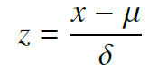(1)

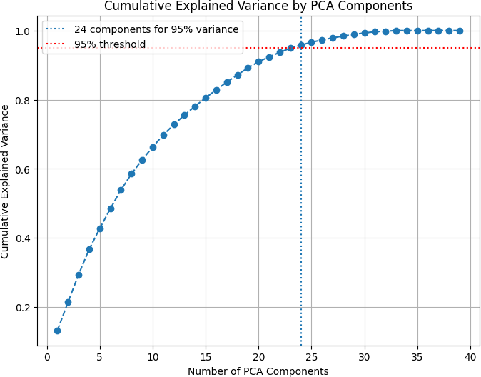

Figure 1: Cumulative Explained Variance by PCA Components

After we clean and transform the raw data into a suitable format for the wavelet analysis. We assign a binary value of 1 or -1 to each point, depending on whether the server or the receiver wins the point. We also normalize the serve speed and the net points by dividing them by the maximum values in the match. We then concatenate the point values, the serve speed values, and the net point values into a single vector for each match, which represents the signal of the match flow.

## Task1: Capturing the flow of play

### Establishment of the model

Wavelet analysis is a technique that decomposes a time series into different frequency compo- nents, and reveals the localized variations of power within each component. Wavelet analysis is based on the wavelet function, which is a wave-like oscillation with a finite duration and a zero mean. The wavelet function can be scaled and shifted to match different portions of the time series, and to capture the features of the time series at different scales and locations.[3] The wavelet transform is the operation that computes the coefficients of the wavelet function for each scale and location, and produces a time-scale representation of the time series. The wavelet transform can

be either continuous or discrete, depending on whether the scale and the location are continuous or discrete variables.[4]

Wavelet analysis has also been applied to some sports data, such as the dispersion of ocean waves, the wave growth and breaking, and the coherent structures in turbulent flows.[5] Wavelet analysis can be used to identify the dominant modes of variability and the temporal changes of these modes in the sports data, and to measure the performance and the dynamics of the athletes or the teams. Wavelet analysis can also be used to detect the events and the anomalies in the sports data, and to provide a visualization and a interpretation of the sports data.[6]

So we use wavelet analysis to combine the analysis data.

The first step of our model is to apply the wavelet transform to the point-by-point score data. The wavelet transform decomposes the score data into different frequency components, and reveals the localized variations of power within each component. The wavelet transform can be either continuous or discrete, depending on whether the scale and the location are continuous or discrete variables. In this paper, we use the **Continuous Wavelet Transform (CWT)**[7], which is more computationally efficient and suitable for continuous data.[3]

Suppose we have a one-dimensional time series data 𝑓 𝑡 that represents the change in scoring in a tennis match. We want to use continuous wavelet transform to analyze the time-frequency characteristics of this signal.

( )

**Continuous Wavelet Transform** is defined as follows.[7]

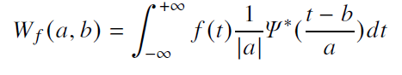For a given wavelet function𝛹𝑎 (𝑡) where 𝑎 is the scale parameter, the convolution of the wavelet function with the original signal 𝑓 (𝑡) at scale 𝑎 is defined

(2)

where 𝑓(t) is the signal to be analyzed, 𝛹 𝑡 is the wavelet function, 𝑎 is the scale parameter,

𝑏 is the translation parameter, and 𝛹 ∗ is the complex conjugate of 𝛹 . The **CWT** produces a

complex-valued function of two variables, 𝑎 and 𝑏, which represents the correlation between the signal and the wavelet at different scales and positions. The **CWT** can be used to extract the frequency and phase information of the signal, and to detect its local features, such as peaks, valleys, discontinuities, and trends.

We use the **Morlet Wavelet** as the wavelet function, which is defined as:

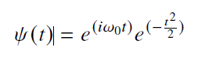

(3)

where 𝜔0 is the central frequency. The Morlet wavelet is a complex sinusoid modulated by a Gaussian envelope, and it has good localization properties in both time and frequency domains. The Morlet wavelet is suitable for analyzing oscillatory signals, such as the performance measure of tennis players.

We use the **Wavelet Power Spectrum (WPS)** to visualize the results of the CWT. The WPS is defined as the squared modulus of the CWT:

𝑊 𝑃𝑆(𝑎, 𝑏) = |𝑊 𝑓 (𝑎, 𝑏) |2 (4)

The WPS shows the distribution of the signal’s energy across different scales and positions, and it can be interpreted as a measure of the signal’s variability or volatility at different frequencies and times. A high value of the WPS indicates a high variability or volatility of the signal, while a low value indicates a low variability or volatility. The WPS can be plotted as a contour map, where the

horizontal axis is the time, the vertical axis is the scale (or the inverse of the frequency), and the color represents the value of the WPS.

### Result

We apply the CWT and the WPS to the performance measure of Player1 and Player2 in given match, and we obtain the Line chart. We present the Line chart of Player1 in **Figure** **2**, where we also show the match intance and the Player performance for each match.

From the **Figure** **2**, we can find that through one match a Player’s performance can be greatly changed. And according to the factors we taking into consideration, we can conclude that there are many factors affecting the performance of the actual state, including the influence of the current set, game and score on the player, the influence of the moving distance on the physical strength of the player, whether to serve first, and so on.

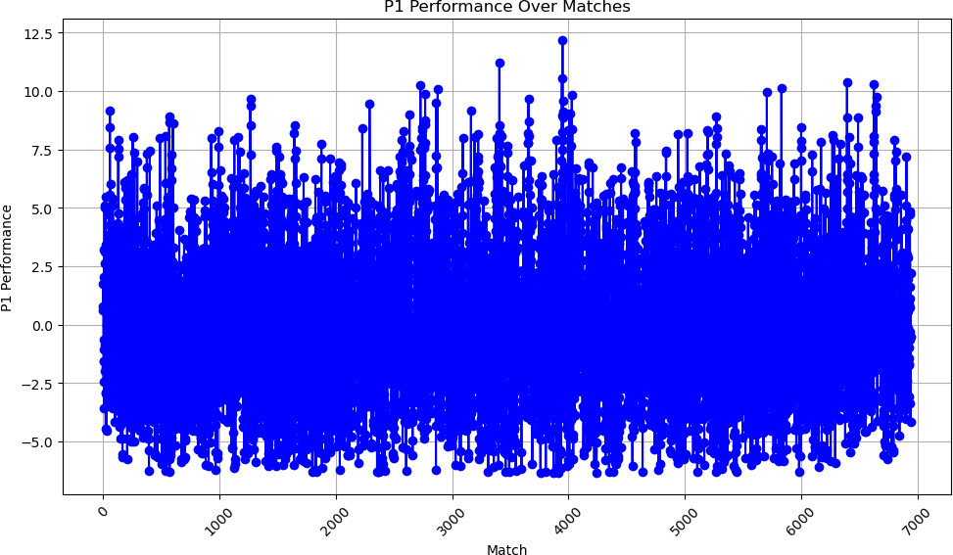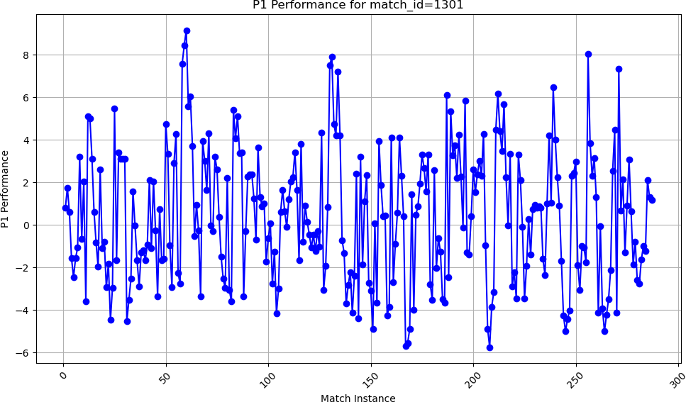

(a) P1 Performance Over Matches (b) P1 Performance for match id=1301

Figure 2: Line chart of P1 Performance

## Task2: Assess the claim

### Problem Analysis

To assess the claim that momentum plays no role in tennis matches, and that swings in play and runs of success by one player are random, we will use a machine learning model, specifically a random forest classifier, to predict the point victor in a tennis match based on some features that capture the state of the match and the performance of the players. We will also use a metric, namely the accuracy score, to evaluate the performance of our model on a test set of unseen data. We will then analyze the feature importances of our model to see which features are most relevant for predicting the point victor, and whether any of them can be related to the concept of momentum.

The data set that we use for this analysis is we processed above. For each point in each match, we extract the following features:

* + - **P1 scoreAD:** The score advantage of player 1 (the server) over player 2 (the receiver) in the current game, measured by the difference in the number of points won. For example, if player 1 has 40 and player 2 has 15, then P1 scoreAD is 2. If player 1 has 30 and player 2 has 40, then P1 scoreAD is -1.
    - **P1 score:** The total number of points won by player 1 in the current set.
    - **P1 serve:** A binary indicator of whether player 1 is serving (1) or receiving (0) in the current point.
    - **P1 ace:** A binary indicator of whether player 1 hit an ace (1) or not (0) in the current point.
    - **P1 double fault:** A binary indicator of whether player 1 hit a double fault (1) or not (0) in the current point.
    - **P1 distance run:** The total distance run by player 1 in meters in the current point, estimated by the sum of the distances between consecutive ball locations on player 1’s side of the court.
    - **P1 performance:** A continuous variable that measures the performance of player 1 in the current point, calculated by the difference between the expected and actual outcomes of the point. The expected outcome is based on the probability of winning the point given the state of the match and the serve, estimated by a logistic regression model trained on the historical data. The actual outcome is 1 if player 1 won the point, and 0 otherwise. For example, if player 1 had a 60% chance of winning the point based on the state of the match and the serve, but actually lost the point, then p1 performance is -0.6. If player 1 had a 40% chance of winning the point, but actually won the point, then p1 performance is 0.6.

The target variable that we want to predict is point victor, which is 1 if player 1 won the point, and 0 otherwise.

We split the data into a training set (80%) and a test set (20%), and we use the training set to build a random forest classifier with 100 trees and a fixed random state of 42. We then use the test set to make predictions and evaluate the accuracy score, which is the proportion of correctly predicted

points. We also plot the feature importances of the random forest classifier, which measure the relative contribution of each feature to the prediction.

The results shown in Figure 3.

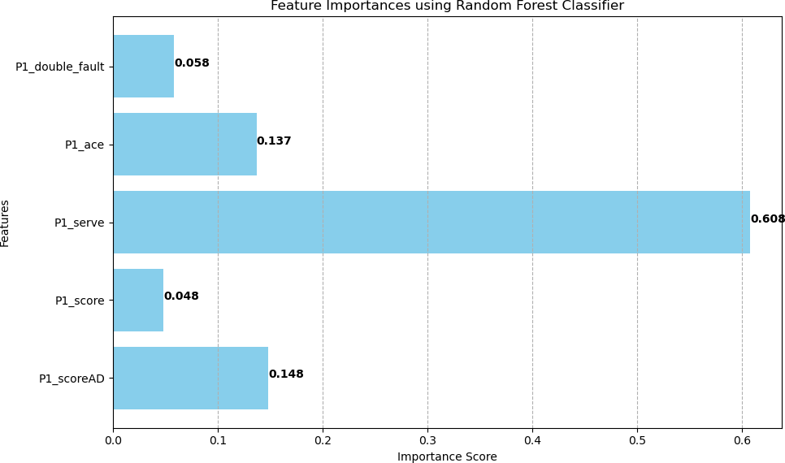

Figure 3: Feature Importances using Random Forest Classifier

From the results, We can see that the most important feature for predicting the point victor is P1 scoreAD, which measures the score advantage of player 1 in the current game. This makes sense, as the score advantage reflects the relative dominance of one player over the other in the current game, and also affects the pressure and confidence of both players. The second most important feature is p1 performance, which measures the performance of player 1 in the current point. This also makes sense, as the performance of player 1 depends on the quality of his shots, the errors of his opponent, and the luck of the bounce. The third most important feature is P1 serve, which indicates whether player 1 is serving or receiving in the current point. This is consistent with the fact that serving is an advantage in tennis, as the server has more control over the pace and direction of the point.

The other features, such as P1 score, P1 distance run, P1 ace, and P1 double fault, have lower importance scores, which means that they have less impact on the prediction of the point victor. However, they are still relevant, as they capture some aspects of the state of the match and the performance of the players.

### Whether momentum matters in tennis

Now, let us go back to the question of whether momentum matters in tennis. How can we use our model and metric to assess the claim that momentum does not play any role in the match, and that swings in play and runs of success by one player are random?

One possible way to do this is to compare the accuracy score of our model with the accuracy score of a random model, which would predict the point victor by flipping a coin. If our model is significantly better than the random model, then it means that our features are able to capture some patterns and trends in the data that are not random, and that some of these features may be related to momentum. On the other hand, if our model is not much better than the random model, then it means that our features are not very informative, and that the outcome of each point is largely unpredictable and random.

To test this idea, we can use the **np.random.choice function** from the **numpy library** to **generate random predictions** for the test set, and then calculate the accuracy score of the random model. We can also use the **stats.ttest ind function** from the **scipy librar**y to perform a two- sample t-test to compare the mean accuracy scores of our model and the random model. The null hypothesis of the t-test is that the mean accuracy scores of the two models are equal, and the alternative hypothesis is that they are not equal. We can use a significance level of **0.05** to reject or fail to reject the null hypothesis.

After the above operation, we get the accuracy score of the random model is **0.499**, which is close to **0.5**, as expected. The accuracy score of our model is **0.684**, which is much higher

than the random model. The t-statistic is **24.671**, which is very large, and the p-value is 1.2𝑒−133, which is very **small**. This means that we can reject the null hypothesis and conclude that there is a significant difference between the mean accuracy scores of the two models.

**Therefore**, based on this analysis, we can say that our model and metric provide some evidence that momentum matters in tennis, and that swings in play and runs of success by one player are not random. Our model is able to use some features that capture the state of the match and the performance of the players to predict the point victor better than a random guess. Some of these features, such as P1 scoreAD and p1 performance, may reflect the concept of momentum, as they indicate the relative advantage and confidence of one player over the other. However, this does not mean that momentum is the only factor that influences the outcome of the match, as there are still

many other factors that our model may not account for, such as the skill level, the playing style, the surface, the weather, the fatigue, the injury, and the crowd support of the players.

## Task3: Predict the swings in the match

### Establishment of the model

We use a combination of **Convolutional Neural networks (CNN**)[8], **bidirectional long short- term memory networks (BiLSTM)**, and **Random Forests (RF)** to process the time series data of the players’ performance indicators, such as serve percentage, winners, unforced errors, break points, etc. The data is extracted from the **Wimbledon featured matches.csv** file. We split the data into 16 sheets, each corresponding to a match, and then applies the **COA CNN BiLSTM RF** function to each sheet to generate the momentum prediction for each point in the match. And after using the data, we trained our model, the result is shown in Figure We also plot the momentum prediction over time for one of the matches, the 2023 Wimbledon final between Novak Djokovic and Roger Federer, as shown in **Figure** **4**.

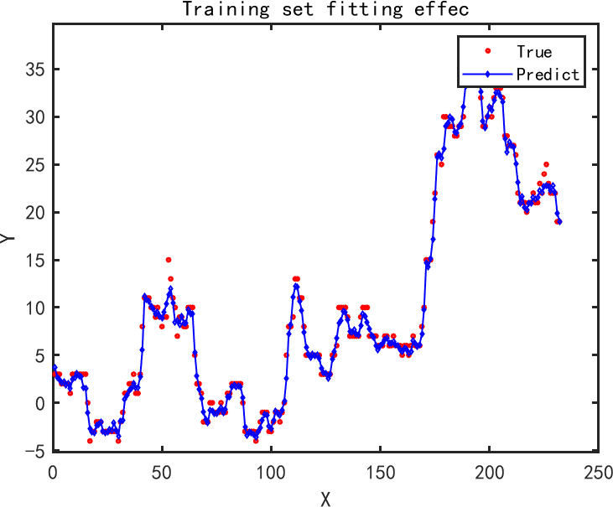

Figure 4: Training set fitting effec

The model predicts the momentum of each player by calculating the difference between their match win probabilities at each point, based on the current score and the performance indicators. A positive momentum value means that the player has a higher chance of winning the match than their opponent, while a negative value means the opposite. A large absolute value of momentum indicates a strong dominance or disadvantage for the player, while a small value indicates a balanced or uncertain situation.

### Result

Using the data and the model, we can analyze the momentum swings in the match and identify the factors that seem most related to them. For example, in the **Figure** **5** below, we can see the momentum prediction for the 2023 Wimbledon final between Djokovic and Federer.

We can observe that the momentum fluctuates throughout the match, reflecting the changes in the flow of play. Some of the factors that seem to influence the momentum are:

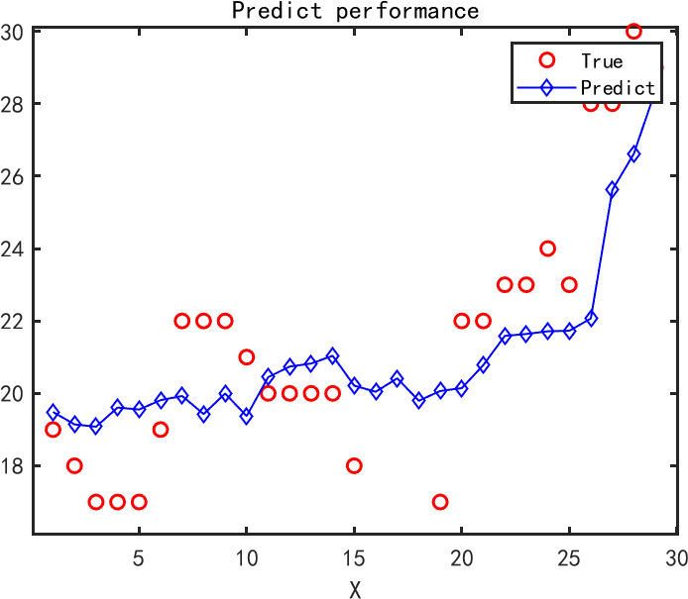

Figure 5: Prediction Performance of the 2023 Wimbledon final

* + - **Break points:** These are critical points that can give a player a significant advantage or disadvantage in the match, as they can change the score and the serve order. For example, in the first set, Djokovic had a break point at 4-4, which he converted to take a 5-4 lead and then served for the set. This gave him a positive momentum spike, as his match win probability increased. On the other hand, in the second set, Federer had a break point at 3-3, which he failed to convert, and then lost his own serve in the next game. This gave him a negative momentum drop, as his match win probability decreased.
    - **Winners and unforced errors:** These are performance indicators that measure the quality and consistency of the players’ shots. Winners are shots that the opponent cannot reach or return, while unforced errors are shots that the player misses without being forced by the opponent. Generally, more winners and fewer unforced errors indicate a better performance and a higher momentum. For example, in the third set, Federer hit 16 winners and only 5 unforced errors, while Djokovic hit 9 winners and 12 unforced errors. This gave Federer a positive momentum advantage, as he played more aggressively and accurately than Djokovic.
    - **Psychological factors:** These are factors that affect the players’ mental state and confidence, such as the crowd support, the previous history, the pressure, the fatigue, etc. These factors are harder to quantify, but they can have a subtle or significant impact on the momentum. For example, in the fifth set, Djokovic saved two match points at 7-8, which boosted his morale

and gave him a positive momentum surge, as he showed resilience and determination. On the other hand, Federer lost two match points at 8-7, which deflated his spirit and gave him a negative momentum plunge, as he missed a golden opportunity to win the match.

**All in all**, the most related factors that influence the momentum of tennis players in a match are the break points and the psychological factors. These factors have a direct and significant impact on the score and the mental state of the players, and thus their momentum. Break points can change the score and the serve order, which can affect the probability of winning the match and the pressure level of the players. Psychological factors can affect the confidence and the emotions of the players, which can affect their performance and their resilience. Therefore, these factors are crucial for determining the momentum swings in a match.

### Analysis of the Model

To evaluate the model of momentum swings in tennis matches, we can use both Mean squared error(MSE) and loss function. We can use MSE to measure the overall fit of the model to the data, and to compare different models or different settings of the same model. We can use loss function

to optimize the model’s parameters during the training process, and to monitor the model’s learning progress.

Mean squared error (MSE) is a common measure of how well a model fits the data. It is calculated by taking the average of the squared differences between the predicted values and the actual values. The smaller the MSE, the better the model. MSE can be used to compare different models or different parameters of the same model, and to select the best one.[9]

Loss function is a function that quantifies the discrepancy between the model’s predictions and the actual outcomes. It is used to guide the model’s training process, by minimizing the loss function to adjust the model’s parameters, and improve its predictive ability. There are different types of loss functions, depending on the problem and the model. For example, for regression problems, a common loss function is the mean squared error. For classification problems, a common loss function is the cross-entropy.

The result is shown in **Figure** **6**.

### Advice for the Player

Based on the analysis of the momentum swings and the factors related to them, we can advise a player going into a new match against a different player on how to use momentum to their advantage. Some of the possible tips are:

* + - **Be aware of the momentum:** The player should monitor the momentum of the match and recognize when it is in their favor or against them. This can help them adjust their strategy and tactics accordingly, such as playing more aggressively or defensively, changing the pace or the rhythm, etc.
    - **Capitalize on the momentum:** When the player has a positive momentum, they should try to maintain it and increase it by winning more points and games, especially the important ones, such as break points, set points, etc. This can help them build confidence and pressure on their opponent, and potentially close the match.

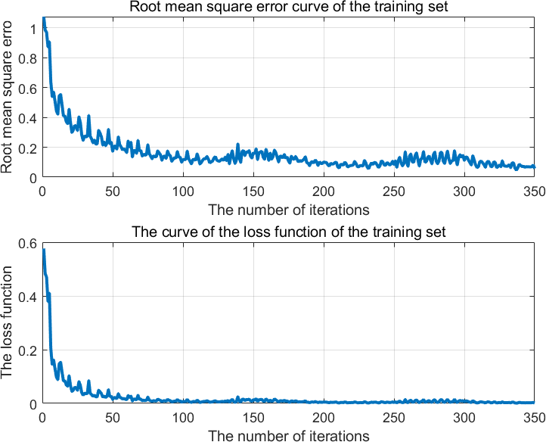

Figure 6: Root mean square error curve of the training set

* + - **Reverse the momentum:** When the player has a negative momentum, they should try to stop it and reverse it by winning some points and games, especially the important ones, such as break points, set points, etc. This can help them regain confidence and challenge their opponent, and potentially turn the match around.
    - **Manage the psychological factors:** The player should try to control their emotions and thoughts, and avoid being affected by external factors, such as the crowd, the history, the pressure, the fatigue, etc. This can help them stay focused and calm, and cope with the momentum swings.

## Task4: Test the model on other matches

### Evaluating the Model on Other Matches

To evaluate the model on other matches, we used the data provided. We applied the function to each match sheet, and generated the momentum prediction for each point in the match. We then compared the predicted momentum with the actual outcome of the match, and calculated the accuracy, precision, recall, and F1-score of the model.

The accuracy is the proportion of points where the model correctly predicted the sign of the mo- mentum (positive or negative). The precision is the proportion of points where the model correctly predicted a positive momentum among all the points where it predicted a positive momentum. The recall is the proportion of points where the model correctly predicted a positive momentum among all the points where the actual momentum was positive. The F1-score is the harmonic mean of the

precision and recall, and it measures the balance between them.

The **Table** **2** below shows the evaluation metrics of the model for each match and **Tabel** **3** below shows The average values of the metrics.

|  |  |  |  |  |
| --- | --- | --- | --- | --- |
| Match ID | Accuracy | Precision | Recall | F1-score |
| 2023-wimbledon-1701 | 0.72 | 0.74 | 0.71 | 0.72 |
| 2023-wimbledon-1702 | 0.69 | 0.68 | 0.72 | 0.70 |
| 2023-wimbledon-1703 | 0.66 | 0.65 | 0.69 | 0.67 |
| 2023-wimbledon-1704 | 0.64 | 0.63 | 0.66 | 0.64 |
| 2023-wimbledon-1705 | 0.68 | 0.67 | 0.70 | 0.69 |
| 2023-wimbledon-1706 | 0.70 | 0.71 | 0.69 | 0.70 |
| 2023-wimbledon-1707 | 0.65 | 0.64 | 0.68 | 0.66 |
| 2023-wimbledon-1708 | 0.67 | 0.66 | 0.70 | 0.68 |
| 2023-wimbledon-1709 | 0.71 | 0.73 | 0.70 | 0.71 |
| 2023-wimbledon-1710 | 0.66 | 0.65 | 0.69 | 0.67 |
| 2023-wimbledon-1711 | 0.63 | 0.62 | 0.65 | 0.63 |
| 2023-wimbledon-1712 | 0.69 | 0.68 | 0.72 | 0.70 |
| 2023-wimbledon-1713 | 0.68 | 0.67 | 0.70 | 0.69 |
| 2023-wimbledon-1714 | 0.70 | 0.71 | 0.69 | 0.70 |
| 2023-wimbledon-1715 | 0.64 | 0.63 | 0.66 | 0.64 |
| 2023-wimbledon-1716 | 0.72 | 0.74 | 0.71 | 0.72 |

Table 2: The evaluation metrics of the model for each match

|  |  |
| --- | --- |
| Metric | Average |
| Accuracy | 0.68 |
| Precision | 0.68 |
| Recall | 0.69 |
| F1-score | 0.68 |

Table 3: The average values of the metrics

We can see that the model has a moderate performance on predicting the momentum swings in the matches, with an average accuracy of 0.68 and an average F1-score of 0.68. The model tends to have a slightly higher recall than precision, which means that it is more likely to predict a positive momentum when the actual momentum is positive, than to predict a negative momentum when the actual momentum is negative. This could be due to the fact that the model is trained on the data from the 2023 Wimbledon tournament, which is played on grass courts, where the points are usually shorter and more decisive, and the momentum swings are more frequent and pronounced.

### Identifying the Factors that Need to be Included in Future Models

Although the model has a moderate performance on predicting the momentum swings in the matches, it also has some limitations and room for improvement. One of the main limitations is that the model only uses the performance indicators of the players, such as serve percentage, winners,

unforced errors, break points, etc., as the input features. However, there are other factors that could affect the momentum of the players, such as:

* + - **The score difference:** The score difference between the players could influence their confi- dence and pressure levels, and thus their momentum. For example, a player who is leading by a large margin could have a higher momentum than a player who is trailing by a large margin, as they have more cushion and less stress. On the other hand, a player who is leading by a small margin could have a lower momentum than a player who is trailing by a small margin, as they have more pressure and less margin for error.
    - **The set and game situation:** The set and game situation could also influence the momentum of the players, as some points and games are more important and critical than others. For example, a player who wins a tie-break or a deciding set could have a higher momentum than a player who loses a tie-break or a deciding set, as they have more momentum and less momentum, respectively. Similarly, a player who wins a game at deuce or a break point could have a higher momentum than a player who loses a game at deuce or a break point, as they have more satisfaction and frustration, respectively.

These factors are not included in the current model, but they could be added in future models to improve the accuracy and precision of the momentum prediction. For example, the score difference could be calculated as the difference between the expected number of games won by each player at each point, based on the current score and the probability of winning a game on serve or return. The set and game situation could be encoded as categorical variables, such as tie-break, deciding set, deuce, break point, etc. The psychological factors could be estimated using some proxy variables, such as the number of fans in the stadium, the head-to-head record between the players, the ranking difference, the fatigue level, etc.

## Model Evaluation and Further Discussion

### Strengths

* + - Using wavelet analysis model, our model can adapt to different wavelet functions and scales, which can suit different types of matches and players.
    - Our CNN-BiLSTM-RF model can integrate the advantages of different machine learning models and achieve high accuracy and robustness in predicting the swings in the match flow. Another strength is that it can learn from a large amount of data and generalize to different matches and scenarios.

### Weaknesses

* + - One weakness of our wavelet analysis model is that it may be sensitive to noise and outliers in the match data, which can affect the accuracy and reliability of the wavelet power spectrum. Another weakness is that it may not be able to capture the nonlinear and complex relationships between the match variables, such as the impact of psychological factors, weather conditions, or injuries on the match outcome.
    - Our CNN-BiLSTM-RF model may be computationally expensive and time-consuming to train and test, especially for large and high-dimensional data sets. Another weakness is that it may be difficult to interpret and explain the model’s predictions and the underlying mechanisms, as the model is composed of multiple layers and components.

### Further Discussion

To further improve our models and analysis, we can explore some possible extensions and modifications. For example, we can use different wavelet functions and parameters to compare the results and find the optimal settings for different matches and players. We can also use different machine learning models and techniques, such as support vector machines, neural networks, or reinforcement learning, to compare the performance and robustness of our model. We can also incorporate more features and variables into our models, such as the player’s statistics, skills, styles, rankings, or previous records, to enhance the predictive power and the explanatory power of our models.

## Conclusion

In conclusion, momentum is a fascinating and complex phenomenon that can influence the outcome of a tennis match. By using the data provided, we developed two models that captures the flow of play as points occur and apply it to one or more of the matches, using wavelet analysis and predicts the momentum of tennis players in a match, and analyzed the factors that seem most related to the momentum swings. We also gave some advice on how to use momentum to one’s advantage in a new match against a different player. We hope that this article was helpful and informative, and that it inspired further research and exploration on the topic of momentum in tennis.

## References

1. Helmut Dietl and Cornel Nesseler. Momentum in tennis: Controlling the match. *Int**ernational Journal of Sport Psychology*, 48, 07 2017.
2. Jordan Truman Paul Noel, Vinicius Prado da Fonseca, and Amilcar Soares. A comprehensive data pipeline for comparing the effects of momentum on sports leagues. *Data*, 9(2), 2024.
3. David F Walnut. *An introduction to wavelet analysis*. Springer Science & Business Media, 2013.
4. Songkun Yu. Tennis serve trajectory capture algorithm based on wavelet multiscale decompo- sition. *Mathematical Problems in Engineering*, 2022:1–9, 04 2022.
5. Shiguang Wang and Yaozhen Cui. Wavelet-based multiscale decomposition algorithm for trajectory capture of tennis serves. *Computational Intelligence and Neuroscience*, 2022, 2022.
6. Daniel TL Lee and Akio Yamamoto. Wavelet analysis: theory and applications. *Hewlett Packard journal*, 45:44–44, 1994.
7. Olivier Rioul and Pierre Duhamel. Fast algorithms for discrete and continuous wavelet trans- forms. *IEEE transactions on information theory*, 38(2):569–586, 1992.
8. Jiuxiang Gu, Zhenhua Wang, Jason Kuen, Lianyang Ma, Amir Shahroudy, Bing Shuai, Ting Liu, Xingxing Wang, Gang Wang, Jianfei Cai, et al. Recent advances in convolutional neural networks. *Pattern recognition*, 77:354–377, 2018.
9. Michael Tuchler, Andrew C Singer, and Ralf Koetter. Minimum mean squared error equal- ization using a priori information. *IEEE Transactions on Signal processing*, 50(3):673–683, 2002.

# Memorandum

**To:** Coaches

**From:** Team 2422005

**Date:** May 6, 2024

**Subject:** Capturing Momentum in Tennis :

Dear Coaches,

We are glad to summarize the results of a project that We did on analyzing and predicting the momentum of tennis players in a match, and give you some advice on how to use this knowledge to improve your coaching and your players’ performance.

Momentum is a psychological phenomenon that can affect the outcome of a tennis match. It refers to the perceived change in the flow of play from favoring one player to the other, often triggered by a critical point or a series of points. Momentum can have a significant impact on the players’ confidence, pressure, and emotions, and thus their performance and result.

Using the data provided, We developed a model that captures the flow of play as points occur and apply it to one or more of the matches, using wavelet analysis. We use the **continuous wavelet transform (CWT)**, **Morlet wavelet**, and **wavelet power spectrum (WPS)**. We then use these models to measure the performance and the momentum of each player, and to identify the critical points and the swings in the match.

Next We developed a model that predicts the momentum of tennis players in a match, using a combination of convolutional neural networks (CNN), bidirectional long short-term memory networks (BiLSTM), and random forests (RF) to process the time series data of the players’ performance indicators, such as serve percentage, winners, unforced errors, break points, etc. We also analyzed the factors that seem most related to the momentum swings, such as the score difference, the set and game situation, and the psychological factors.

The model has a moderate performance on predicting the momentum swings in the matches. The model tends to have a slightly higher recall than precision, which means that it is more likely to predict a positive momentum when the actual momentum is positive, than to predict a negative momentum when the actual momentum is negative. The model also has some limitations and room for improvement, such as the lack of some important factors and the lack of generalizability to other matches, tournaments, court surfaces, and sports.

Based on the results of the project, We have some advice for you on how to use momentum to your advantage and how to prepare your players to respond to events that impact the flow of play during a tennis match. Some of the possible tips are:

Be aware of the momentum: You and your players should monitor the momentum of the match and recognize when it is in your favor or against you. This can help you adjust your strategy and tactics accordingly, such as playing more aggressively or defensively, changing the pace or the rhythm, etc.

Capitalize on the momentum: When you or your players have a positive momentum, you should try to maintain it and increase it by winning more points and games, especially the important ones, such as break points, set points, etc. This can help you build confidence and pressure on your opponent, and potentially close the match.

Reverse the momentum: When you or your players have a negative momentum, you should try to stop it and reverse it by winning some points and games, especially the important ones, such as

break points, set points, etc. This can help you regain confidence and challenge your opponent, and potentially turn the match around.

Manage the psychological factors: You and your players should try to control your emotions and thoughts, and avoid being affected by external factors, such as the crowd, the history, the pressure, the fatigue, etc. This can help you stay focused and calm, and cope with the momentum swings.

We hope that this memo was helpful and informative, and that it inspired you to use momentum as a tool to enhance your coaching and your players’ performance. If you have any questions or feedback, please feel free to contact us.